**WIRELESS SENSOR NETWORK (WISENET)**

**BY**

**SAIDU ABDULLAHI**

**ST/CS/ND/19/260**

**A SEMINAR PRESENTED TO THE DEPARTMENT OF COMPUTER SCIENCE, SCHOOL OF SCIENCE AND TECHNOLOGY, FEDERAL POLYTECHNIC MUBI, ADAMAWA STATE, NIGERIA**

**NOVEMBER,2021**

**ABSTRACT**

*Wireless sensor network is a wireless sensor network that monitors environmental conditions such as light, temperature and humidity. This network contains nodes called "motes" that form the ad-hoc network to transmit this data to a computer that acts as a server. The server stores data on a website where it can be retrieved and analyzed using web-based interactions.*

**INTRODUCTION**

David(2004)In the last few years there has been the emergence of many new wireless technologies that have hit the market recently. While the standard is to provide higher and higher data rates, there are many existing and new applications that do not require such high bandwidth, but can benefit greatly from a wireless communication link. Examples of such programs are wireless sensor networks. Its main purpose is to develop a low-power wireless advertising network made up of small distributed sensors that are independent and able to communicate with the outside world. wireless sensor network will enable the monitoring and control of the natural and environmental parameters of various applications. For example, wireless sensor network will monitor the safety and security of future homes and offices. wireless sensor network first goal is to build a new hardware platform to use the most efficient new microcontrollers and additional features.

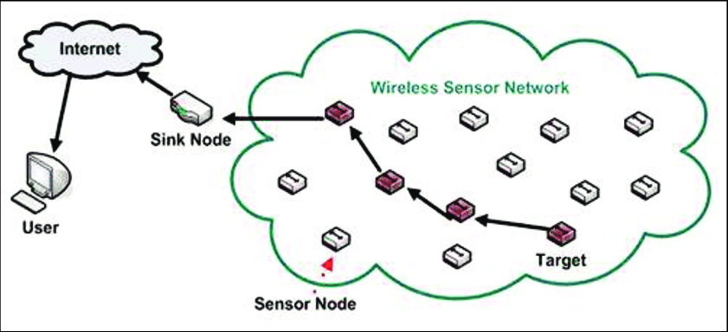

**LITRETURE REVIEW**

Wireless sensor Networks

Khan(2006) The Wireless Sensor Network (WSN) has hundreds of small, low-cost nodes with limited memory, capacity, and processing power. In this type of network, advances in wireless telecommunications have led to the introduction of low-cost, low-power, multitasking and short-range sensors. Cheap, smart sensors, connected to the network via wireless links and widely used, offer unprecedented opportunities to monitor and control homes, cities, and the environment. In addition, network-connected sensors use a variety of applications in the defense environment, developing new testing and monitoring capabilities The ability to self-locate can be a very desirable feature of wireless sensor networks. For environmental applications for example forest fire monitoring, water quality monitoring, the measurement data is empty and does not contain information on location where the data is obtained. In addition, location measurement may enable many applications such as asset management, transportation, access detection, traffic light monitoring, health monitoring, re-inspection and surveillance. King(2006) large wireless sensor networks utilizing a large number of inexpensive and low-power sensors have been developed. Inside the wireless sensor network, a large amount of small, battery-powered sensors are scattered across the visible area. Each sensor in the sensor network collects data, for example, vibration sensations, temperature, radiation and other environmental factors. The wireless sensor network (WSN) covers hundreds to a large number of sensors with multiple low-power functions, operating within an unsupervised environment, and the ability to hear, count and communicate and other characteristics such as temperature and pressure. Prashant and Varun(2015) Sensory nodes hear or measure visual data in a controlled environment. A continuous sensory analog signal is digitally digitized to an analog-to-digital converter and sent to controls for further processing. The sensory nodes are small in size, have very low energy consumption, operate at high volume density, and will be independent and environmentally friendly. Wireless sensor networks are particularly interesting in remote areas, or at all times when a large number of sensory nodes should be used. Local concern is important when there is uncertainty about a particular situation.

If the sensor network is used to monitor the temperature inside a building,it may not be able to detect the exact position of the node. However, in the event that a sensor network is used to monitor the temperature within a remote forest, the nodes that can be planted from the aircraft and the exact location from which the entire sensor may be unknown. An active local action algorithm can use all discarded information using motes to calculate each position(Matthias and James, 2013)

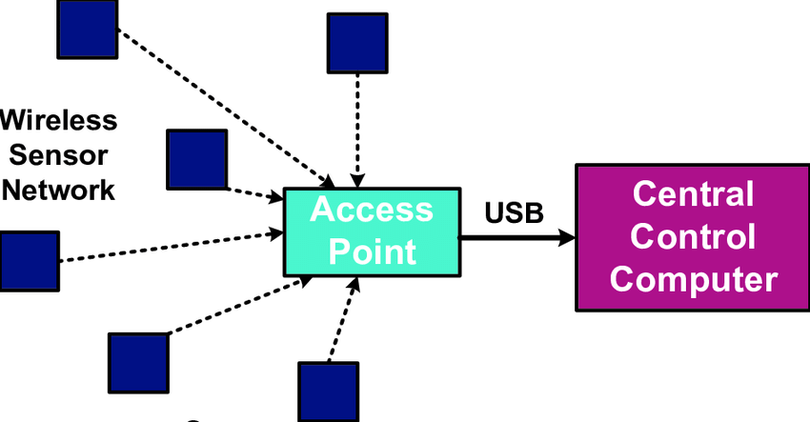

**ADVANTAGES AND DISADVANTAGE**

**ADVANTAGES**

1. Setting up a network can be done without a fixed infrastructure.
2. Suitable for inaccessible areas such as the sea, mountains, rural areas or deep forests, and also It may install new devices at any time.
3. Adaptable to situations where there is a need for additional work space. And Startup prices are cheap.

**DISADVANTAGE**

1. They are less secure because hackers can access and access all information.
2. It is much harder to repair compared to a wired network.
3. It is easily disturbed by the environment (walls, microwave, large distances due to signal reduction, etc.)

**Applications of Wireless Sensor Networks**

Wireless Sensor Networks applications include tracking, monitoring and control. Preetam and Amrit(2013) )Wireless Sensor Networks are widely used for accommodation monitoring, tracking, nuclear reactor control, fire detection, and traffic monitoring. Location monitoring Wireless Sensor Networks is used in an area where a particular incident may be monitored. For example, a variety of sensors may be used in a battlefield to detect enemy intrusion rather than using land mines.

1. Process Management: Area monitoring is a very common using Wireless sensor networks. In area monitoring, the Wireless sensor networks is deployed spanning a region where some phenomenon is usually to be monitored. A military example may be the use of sensors detect enemy intrusion

2. Healthcare monitoring: Wearable devices are applied to the body surface of the human or maybe at close proximity from the user e.g. body position measurement and of the person, overall monitoring of ill patients in hospitals and also at homes.

3.Environmental/Earth sensing: They share any additional challenges of harsh environments and reduced power supply.

5. Forest fire detection: A network of Sensor Nodes is usually positioned in a forest to detect every time a fire has begun. The nodes is usually with sensors to measure temperature, humidity and gases which are produced by fire within the trees

6. Landslide detection: A landslide detection system uses a wireless sensor network to detect the slight movements of soil and modifications to various parameters that will occur before or throughout a landslide.

**CONCLUSIONS**

Wireless sensor networks consist of sensor nodes, independent, designed to monitor and record a variety of situations. In this dissertation, a comparative study was conducted based on the use of wireless sensor networks. In particular, it explored wireless sensor networks used in industry, smart homes and ecosystems that create an intelligent environment, capable of meeting people's needs. An industrial wireless sensor network in the industrial area is the best technological choice.

**RECOMMENDATION**

In the future a patient or visually impaired patient program may be created, so that it can take care of itself. With the use of wireless sensor networks, the monitoring of natural applications has been greatly improved. Apart from the large amount of power used by nodes in wireless sensor networks, the benefits to the user are many. Research should be done to find and create the right principles to measure the power used by the system.

1. mobile devices can be integrated into the wireless sensor network, in order to process additional data and increase the number of applications to interact with the network.
2. in order to achieve effective communication on network data. For best practice, proper planning should be done from the outset. The design of the network, all the internal limits of the industrial area and its requirements must be considered.

**REFERENCES**

David,M.(2004). wireless technologies that have hit the market recently.*Journal of University of Hong Kong, 01(04).*

King,Y. Cheng (2006). Large wireless sensor networks utilizing a large number of inexpensive and low-power sensors have been developed. *The Journal University of Hong Kong,02(06).*

Khan, P. (2006). Khan(2006) The Wireless Sensor Network (WSN) has hundreds of small, low-cost nodes with limited memory, capacity, and processing power: *International Journal of Computer Applications, 9(10).*

Matthias, R. Matthias,W.(2013). Action algorithm can use all discarded information using motes to calculate each position *HCTL Open International Journal of Technology Innovations and Research, 01(13)*

Preetam ,S. Amrit ,S.(2013). Wireless Sensor Networks are widely used for accommodation monitoring, tracking, nuclear reactor control,.*HCTL Open International Journal of Technology Innovations and Research, 02(13).*

Prashant ,T. Varun , P. (2015). Sensory nodes hear or measure visual data in a controlled environment. *HCTL Open International Journal of Technology Innovations and Research (IJTIR), 14(15)*

being monitored (heat, pressure, sound, light, electro-magnetic flux, vibration, etc.), the

big event needs to be reported to at least one in the base stations, which often can than

take some appropriate action (e.g., send some text online or even a satellite). Wireless

sensor networks are utilized extensively within the water/wastewater industries. Facilities

not wired for power or data transmission can be monitored using industrial wireless I/O

devices and sensor nodes powered by solar panels or battery packs. Wireless sensor

networks are able to use numerous sensors to detect the existence of vehicles for

vehicles detection. Wireless sensor networks may also be employed to control the

temperature and humidity levels inside commercial greenhouses. If the temperature and

humidity drops below specific levels, the greenhouse manager might be notified via e-mail

or a cellular telephone text, or host systems can trigger misting systems, open vents, first

turn on fans, or control a multitude of system responses. Because some wireless sensor

networks are super easy to install, they've also been simple move if the needs with the

application change [2].being monitored (heat, pressure, sound, light, electro-magnetic flux, vibration, etc.), the big event needs to be reported to at least one in the base stations, which often can than take some appropriate action (e.g., send some text online or even a satellite). Wireless sensor networks are utilized extensively within the water/wastewater industries. Facilities not wired for power or data transmission can be monitored using industrial wireless I/O devices and sensor nodes powered by solar panels or battery packs. Wireless sensor networks are able to use numerous sensors to detect the existence of vehicles for vehicles detection. Wireless sensor networks may also be employed to control the temperature and humidity levels inside commercial greenhouses. If the temperature and humidity drops below specific levels, the greenhouse manager might be notified via e-mail or a cellular telephone text, or host systems can trigger misting systems, open vents, first turn on fans, or control a multitude of system responses. Because some wireless sensor networks are super easy to install, they've also been simple move if the needs with the application change [2].